Project Performance Test

Date | 04 July 2026
Team ID
Project Name | Cosmetic Insights: Navigating Cosmetics Trends and Consumer Insights with Tableau
Maximum Marks

Model Performance Testing:
Project team shall fill the following information in model performance testing template.
S.No. | Parameter | Screenshot / Values
 | Data Rendered | Total records rendered: 1472 rows, 13 fields (Tableau Data Source screenshot pettandi)  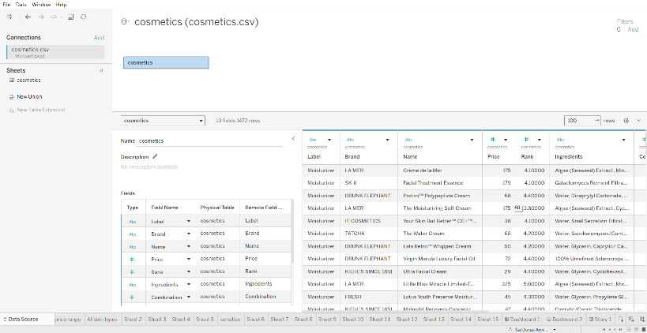
 | Data Preprocessing | Removed inconsistencies, created calculated fields, categorized price ranges, validated data
3. | Utilization of Filters | Filters used: Brand Filter, Price Range Filter, Skin Type Filter
4. | Calculation fields Used | Calculated fields: Price Range, Average Price, Count of Products, Skin Type Analysis
5. | Dashboard design | No. of Visualizations/Graphs: 8  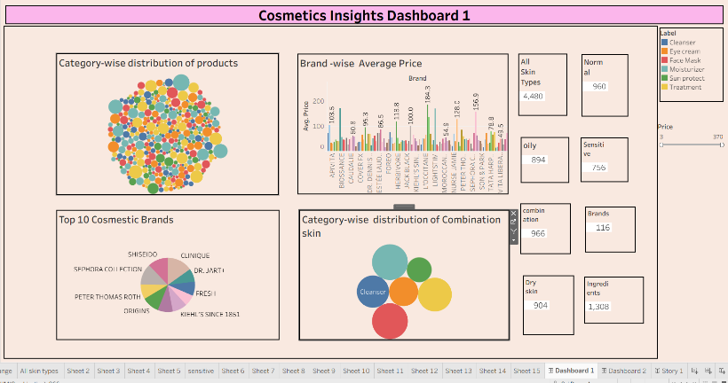  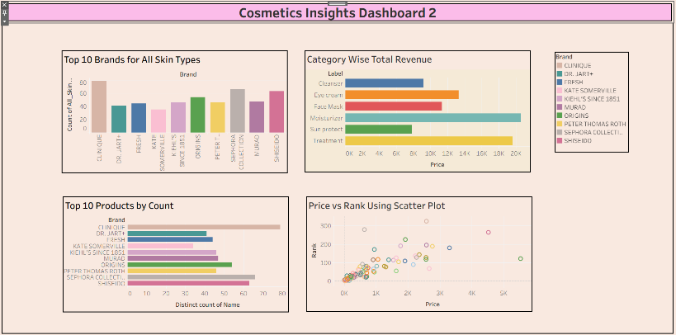
6 | Story Design | No. of Visualizations/Graphs: 2 Dashboards + 1 Story  